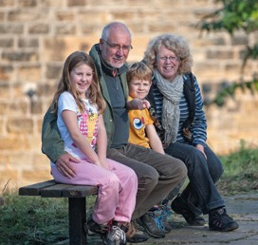
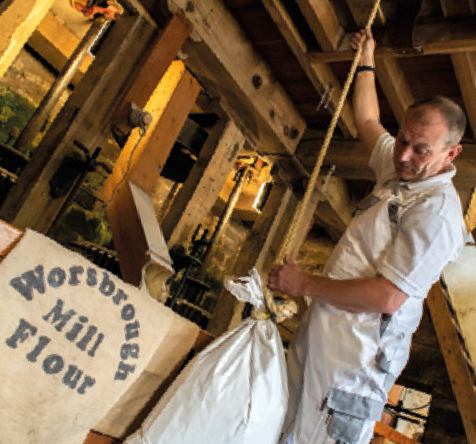
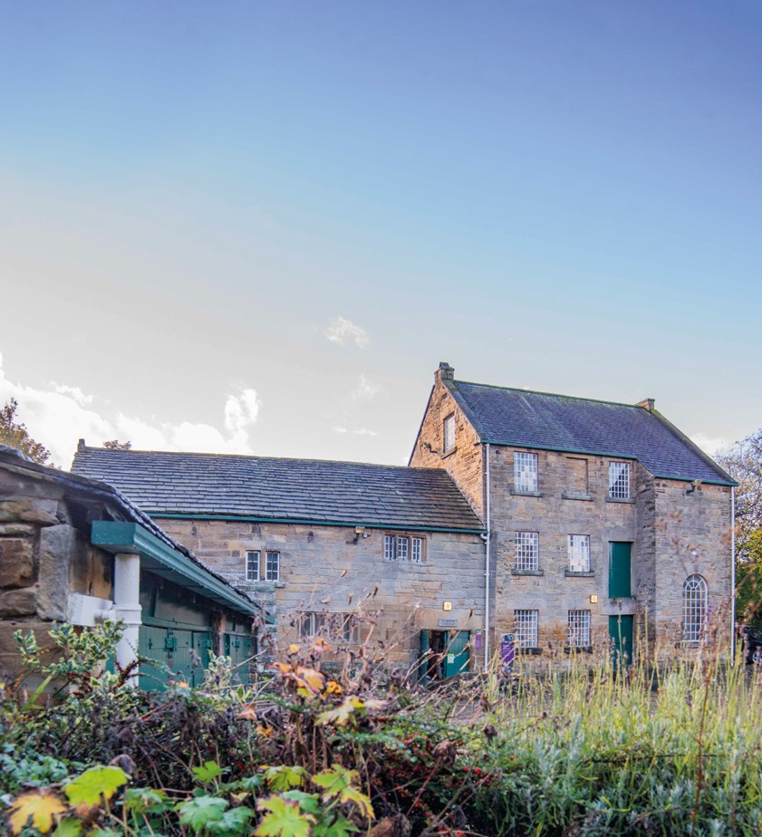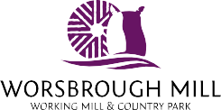

Discover Worsbrough Mill & Country Park

There’s lots on offer at Worsbrough Mill
Explore Worsbrough
Wonder at wildlife, make special memories and see history come to life.

Experience a stunning ⁸

watermill right in the 6

heart of South Yorkshire. 10

Enjoy market days, baking 9
inspiration and festivals.

7

Spend days out with friends and family.
Stop by the tearooms for tasty treats and let the kids have fun in the playground.
1
3 4 2
5

10

Parking this way

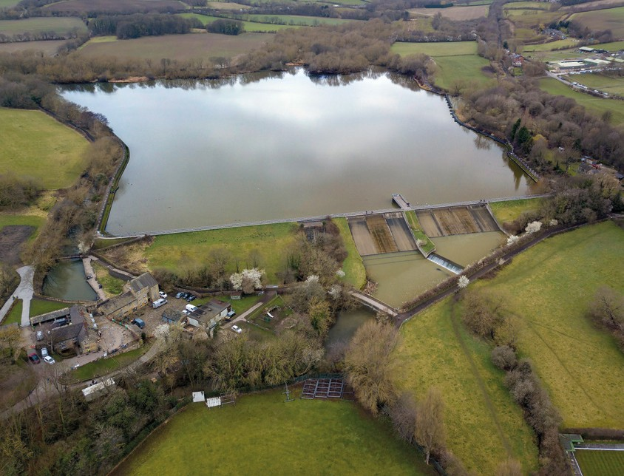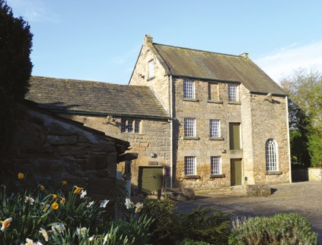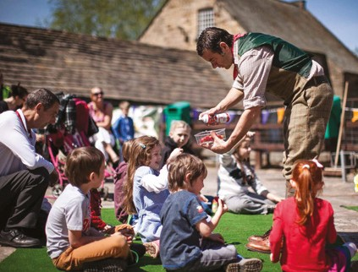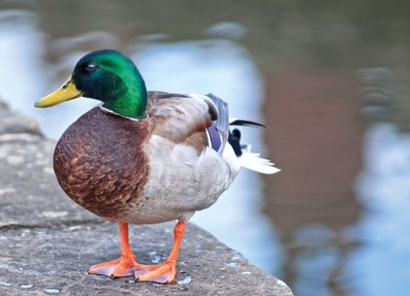

Discover reservoir strolls, spectacular views, bustling wildlife, and birds along the way.

1 Worsbrough Mill
2 Play Area
3 Mill Shop, Bakery and Visitor Gallery
4 Learning Space
5 Millers Tea Room
6 Bird Hide

7 Mill Pond
8 Wigfield Farm
9 Reservoir Walk
10 Trans Pennine Trail WC
Parking Walk Route

Keep a look out as you explore the Country Park.
You’ll discover willow sculptures, stepping stones, animal carvings and more!

Discover the Mill

Our millers produce quality organic flour using skills and sustainable technology that date back centuries.

Explore the Mill Watch the waterwheel and millstones turn.
Chat to the Millers, witness their skills. Discover an amazing history.
Born to Bake! Check out the fantastic creations of our bakers. From home enthusiasts to master bakers, and from cafes to
patisseries, our flour is a real favourite.
Come along and see just a few of the things you can make with
Worsbrough flour.

Using our flour? Send us photos of your bakes to:
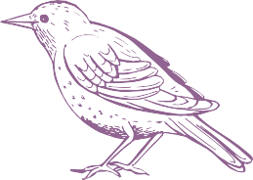flour@barnsley.gov.uk and we’ll share them with others.
Fun family things to do!
Enjoy exploring, special events and lots of outdoor activities.
Watch our waterwheel. Don’t get splashed!
Stand on the pier. Feel the fresh breeze race across the res!
Take some flour home and pick up a recipe too. Have a go at baking!
Pop across to see our animal friends at Wigfield Farm!
Find the bird hide. Which of our feathered friends can you spot today?
Explore the mill. Can you find all the mice?

Our Grain
The grain we use comes from carefully selected farms here in the UK.
We mill wheat, rye and spelt which is organic, meaning no artificial fertilisers and fewer pesticides are used.

Strolls, views, water and wildlife

Our Flour
We produce a variety of organic stoneground flour. You can buy them all at the mill shop in a variety of pack sizes.
Contact us to find out more about deliveries or mail order.
Experience the Mill When the mill is in action, chat to our millers about what they do. At other times, you’re welcome to explore the mill on your own too.

A haven for wildlife
Our reservoir, wet woodlands and meadows are
important habitats

Millers Tea Room

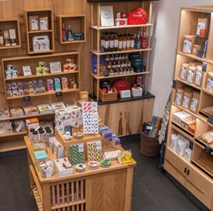Enjoy this bustling tearoom situated in the historic mill cottage.
A Millennium of Milling
Millers have produced flour here, using traditional methods, for around 400 years.
The Visitor Gallery Our new visitor space offers a place to discover more about the Mill’s fascinating past.
The oldest part of our mill dates back to 1625. As the Industrial Revolution
swept through South Yorkshire, the mill got bigger.
Take a tour. Discover the stories of those who’ve lived and worked here. Discover skills and knowledge that have been passed on, generation after generation.
The Mill Shop
Our shop is a haven for budding bakers, selling a range of flour and baking products. There’s plenty for wildlife enthusiasts too.

Our reservoir has been here for over 220 years. It was built to provide water for a new canal as local industry grew. It’s now the perfect place to stroll, enjoy amazing views and discover nature.

The Bird Hide
Our bird hide screen was created by artist Dan Jones, with funding from the Arts Council. Find it on
the north side of the reservoir. Stay a while. Spot birds that live here and others stopping by.
for lots of species including willow tits, harvest mice and chimney sweeper moths. We have lots of bats too!

Pop in for hot drinks, a takeaway treat, tasty sandwiches and more.
Try a delicious stone-baked pizza made with flour from the mill.

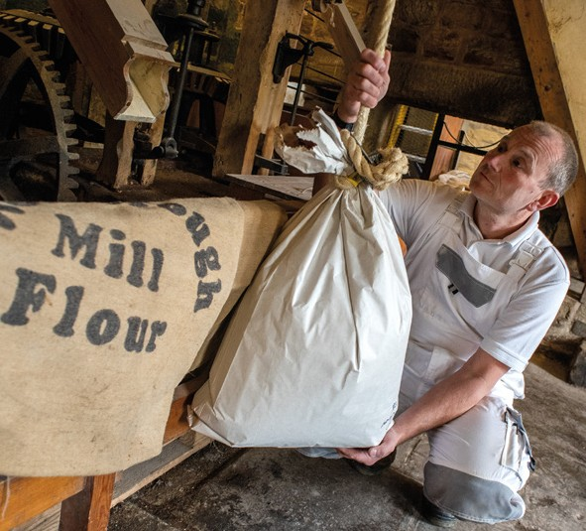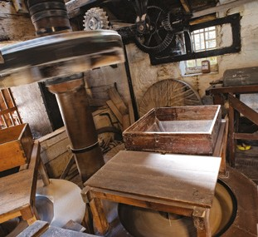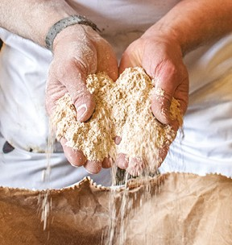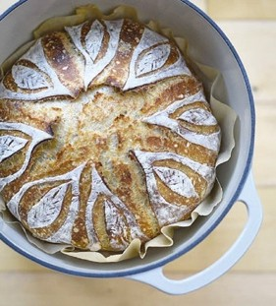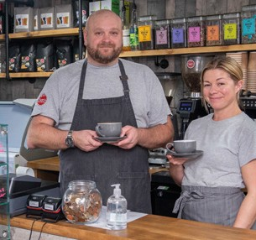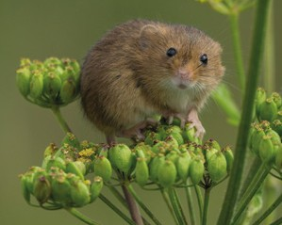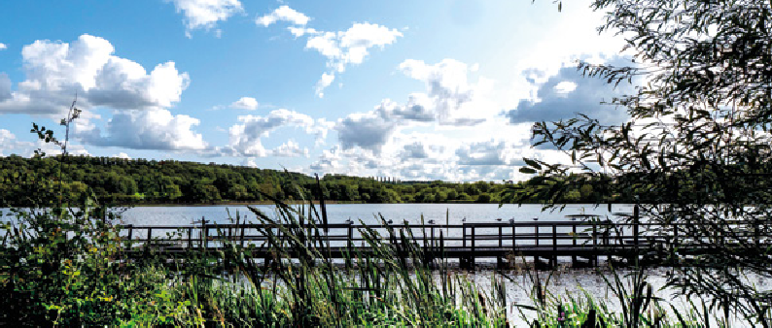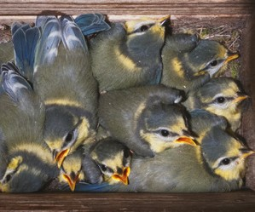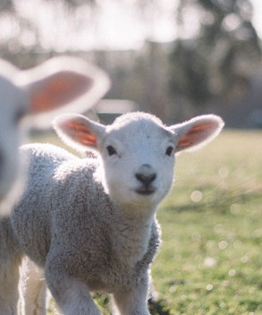Wigfield Farm & Trans Pennine Trail Just to the north of the reservoir and a short walk away, you’ll find Wigfield Farm – a real family favourite, a working farm with lots to do and animal friends to meet.
Our reservoir and woodland have been awarded SSSI status (Site of Special Scientific Interest)
Enjoy al fresco dining in the sun or eat inside if the weather’s not
so good.
Look out for Bistro Nights and other special events.

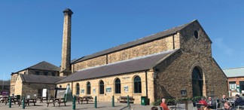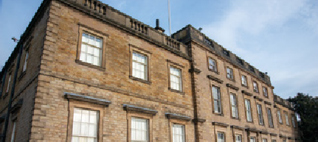How to get here
Discover Barnsley Museums
Barnsley Museums look after other sites too. Each have incredible histories and make for fantastic days out.

Experience Barnsley
www.experience-barnsley.com

Cooper Gallery
www.cooper-gallery.com

Elsecar Heritage Centre
www.elsecar-heritage.com

Cannon Hall Museum
www.cannon-hall.com
Follow brown signs from nearby J36 of the M1. Regular buses from Barnsley Interchange.
Worsbrough Mill & Country Park, Worsbrough,
Barnsley S70 5LJ
worsbroughmill@barnsley.gov.uk 01226 774 527
www.worsbrough-mill.com
Find out more about what’s happening at the Mill:
@WorsbroughMill Worsbrough_mill_flour
Don’t forget to share pictures of your visit with us!

Opening hours
Our car park is open 7 days a week, but is not open 24 hours. Tearoom open 7 days a week 9:30am-4pm. Shop and Mill open Wednesday – Sunday, 10am-3pm.
Discover more online:
www.barnsley-museums.com
Follow us on social media:
@BarnsleyMuseums

